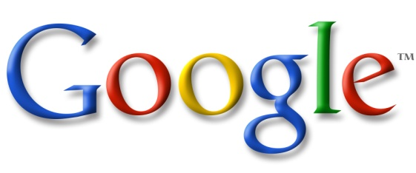Google Scholar Handout 2015

What is Google Scholar: Google Scholar “covers academic papers from sensible websites”, and has an extensive database of reported cases from state and federal courts.

How to find: http://www.scholar.google.com

Settings – Library Links: Shows you if the named library holds books or articles in the results list. For example, putting “Hofstra University” in the Library Links will tell you – when you are off-campus - if access to an article may be obtained through either the Law or Axinn Library subscription databases. As a current Hofstra student you may access the article off campus with the proper login.

About Google Scholar – Search – Coverage
Look at Content Coverage for Accuracy | Reliability | Currency | Comprehensiveness

PRO | CON
It is free. | It is not comprehensive and we do not know true scope of coverage.
It is easy to use. | It does not have the granularity & flexibility of the major commercial databases.
It searches databases such as Hein Online & JSTOR as well as appropriate free websites. Searches across multiple disciplines and not just law. | Because of the algorithm used the search bots do not find all relevant materials in the commercial databases.
U.S Supreme Court since 1791  Federal Courts since 1923  All state appellate courts since 1950 | Some older Federal & State case law is still relevant.  We do not know how frequently the case law database is updated.
It is reasonably accurate for what it finds. | There is duplication of articles and case law.
There is a “Cited By” function to find subsequent authority that has cited the case. The depth of discussion is represented by horizontal bars next to each case name. | Shepard’s, KeyCite & BCite all provide more citation analysis and whether or not the case is still good law.
It permits user to filter by court and by date. | Commercial services offer more filter options.
User can search within the Cited By articles/case law. | Commercial services permit searching within results at more levels.
It has an advanced search function. | Commercial services have advanced and Boolean search functions.
 | Does not have statutes, codes or regulations.
 | No history or trail to help you track your searches.
Google Scholar is a start point. | Google Scholar should not be the only source used or the end point.

Overview & Searching: Basics on how Google Scholar works and some good research tips including Advanced Google Scholar.

Google Scholar Blog: http://googlescholar.blogspot.com

Example search query: same-sex marriage
Result list default is “relevance”
Switch to “date” – notice that the result list says … added in the last year, sorted by date
Back to “relevance” and select for “Since 2014” – different from the “date” list
Modify search in Advanced Search to “in the title of the article”.
Articles – More than just law publications
Legal Documents – Case Law – Select or Filter by Court/Jurisdiction
Cited By – How Cited – Related Articles – Versions – Cite
Cited By: can search within results
Filters on Left
Advanced Search – Menu in query box

Google Scholar is an okay resource to start your legal research, but it should not be the only resource used or where you end your research.

Google Scholar Research Guide: http://libguides.law.du.edu/google-scholar

Advanced Search Tips:

http://www.google.ca/advanced_search

“search query” add quotes for the exact phrase
Add a dash/minus (-) before a word to exclude it from results
Add a tilde (~) before a word to include synonyms

More:
Operators: http://support.google.com/websearch/bin/answer.py?hl=en&p=adv_operators&answer=136861
Tips & Tricks: http://www.google.com/insidesearch/tipstricks/

http://help.heinonline.org/blog/2009/12/heinonline-or-google-scholar-why-you-should-start-your-research-in-heinonline-first-part-ii/

Prepared by Tricia Kasting, February 2015

